Bridge Tester Operator’s Manual

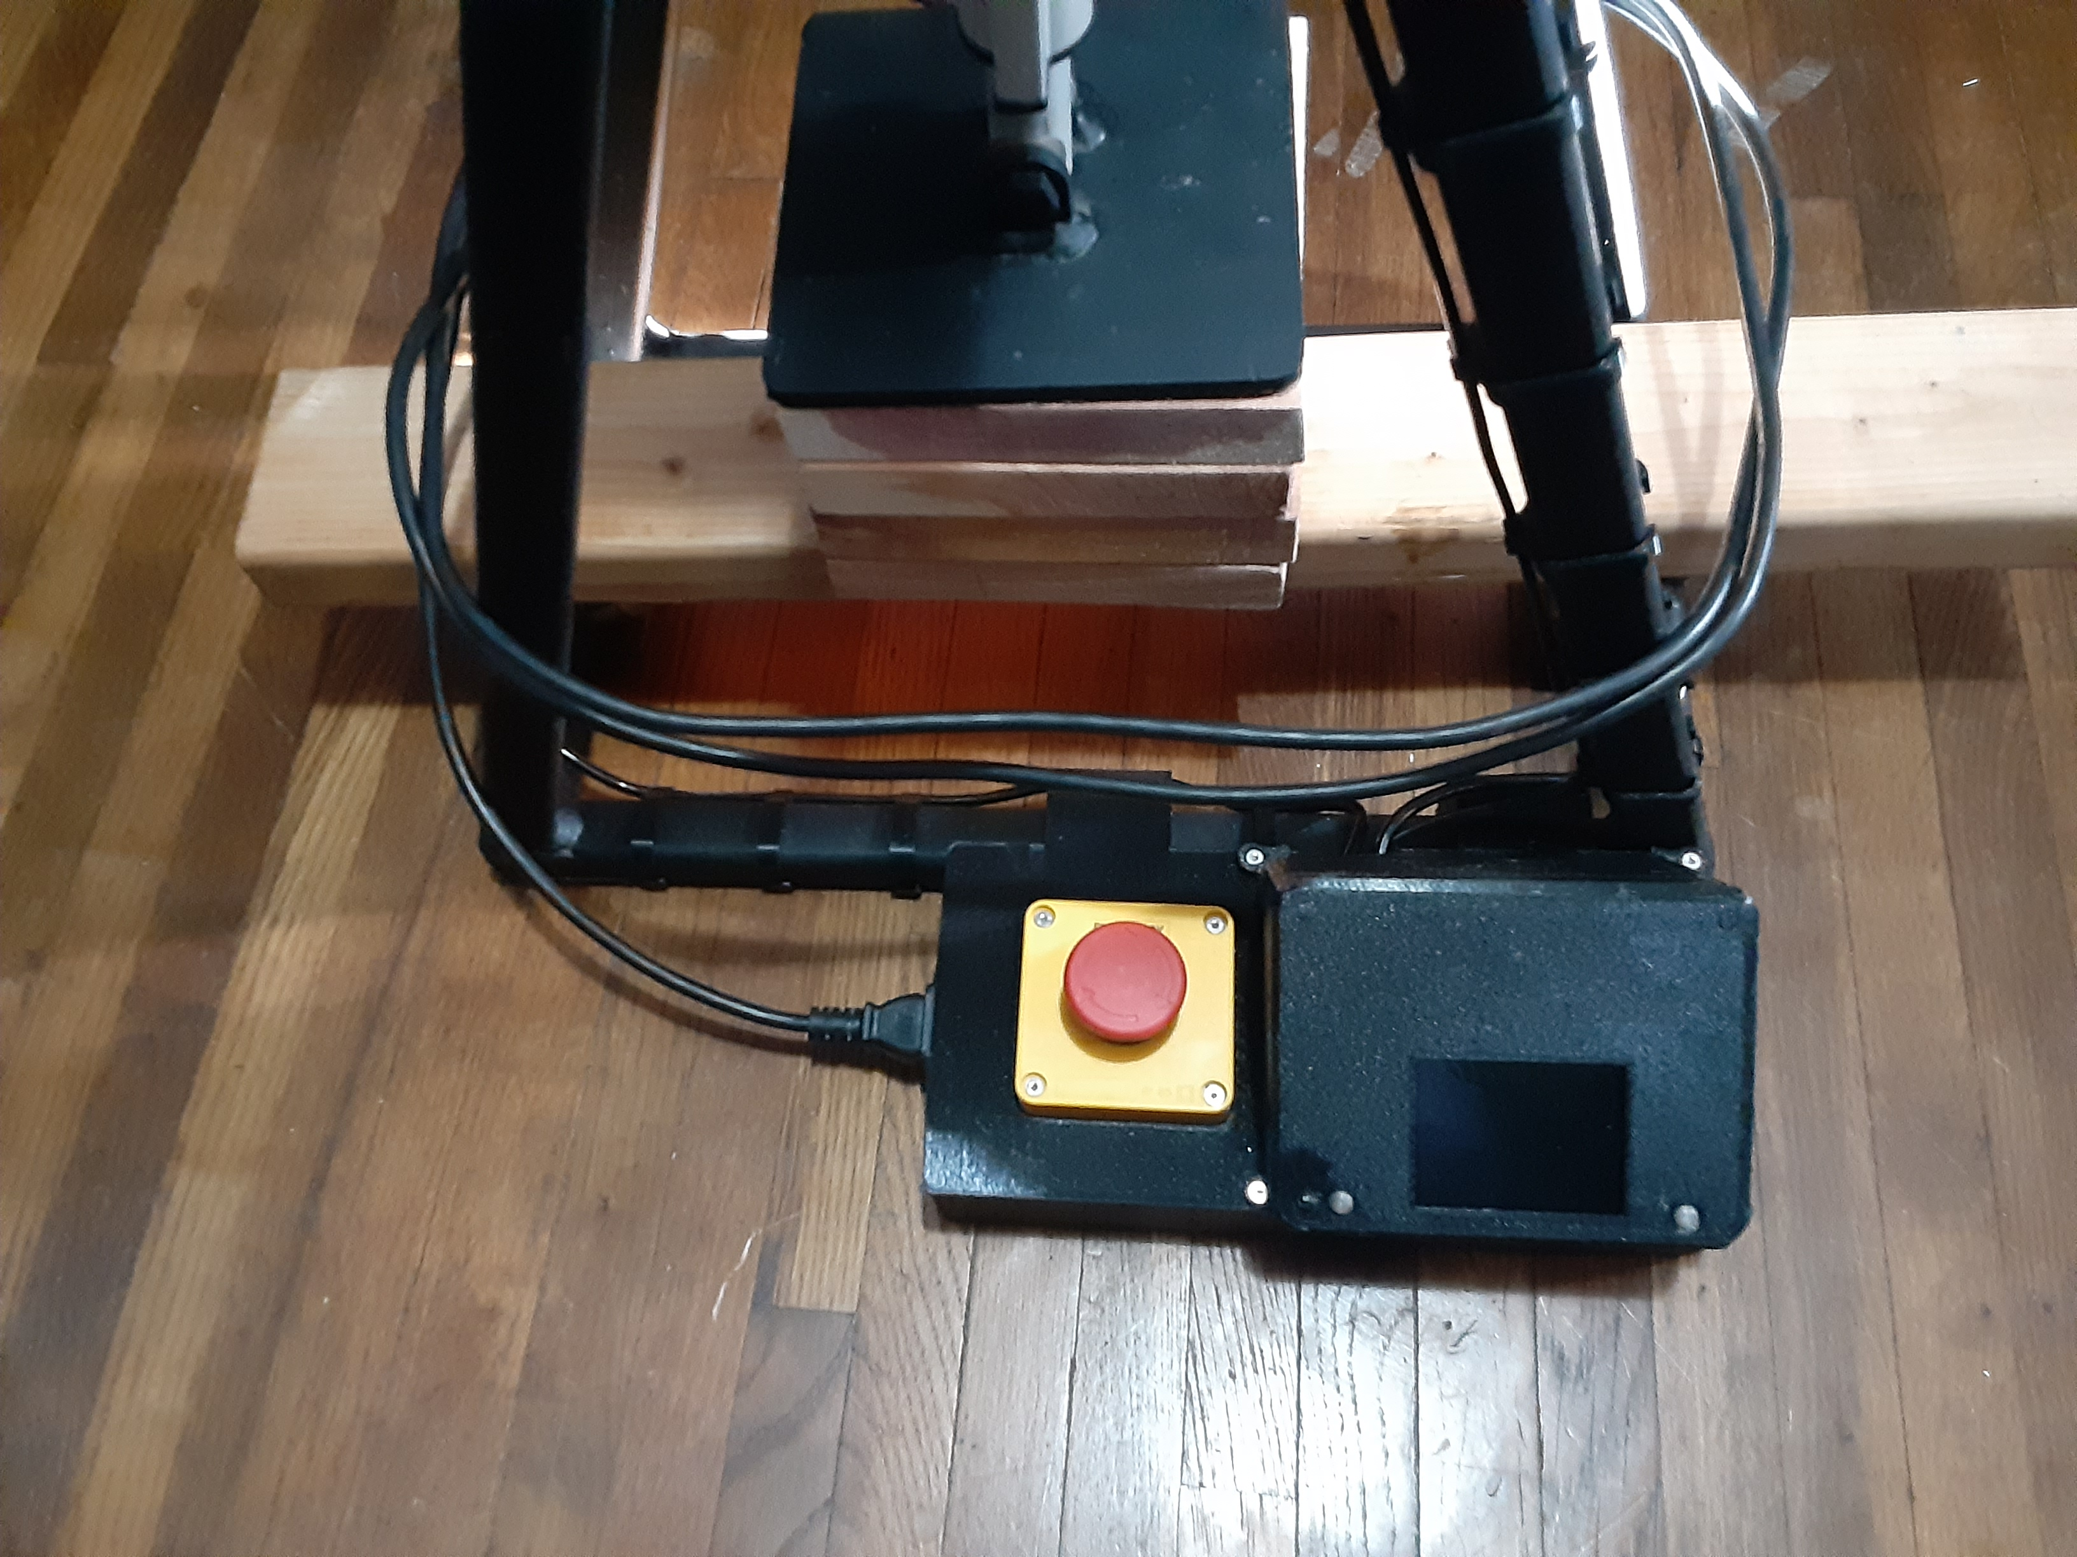
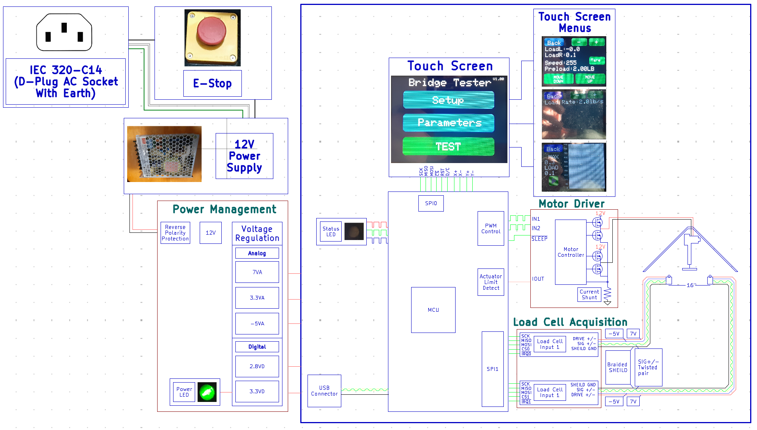

Table of contents

Cover page 1
1. Introduction 2
2. System Characteristics 3
3. Operation Instructions 4
3.1 User Interface Design Philosophy 4
3.2 Setup 4
3.3 Testing 7
3.4 End Testing and System Reset 8
4. Design Info 9
4.1 Electrical 9
4.11 AC Power Input 9
4.12 Power Supplies 9
4.13 MCU 10
4.14 HID 10
4.15 Motor Driver 10
4.16 Load Cells 10
4.2 Software 11
4.21 Libraries 11
4.22 Functions 11
4.23 Uploading Programs 12
5. Definitions 14

1. Introduction
This bridge tester is a custom device designed to facilitate in measuring the strength and structural integrity of popsicle stick bridges. This tester allows accurate measurements of a bridge's load-bearing capacity with better repeatability and safety compared to traditional methods. The design makes use of a basic resistive color touch screen to setup and start each test. This manual provides guidance on setting up, operating, and maintaining the bridge tester. It includes practical tips and troubleshooting advice to ensure smooth operation.

2. System Characteristics
 | Min | Typical | Max | Unit | Conditions
Applied Force | 440 | 700 | 880 | lb | @15-30°C
Force Resolution | 0.1 | 1.0 |  | lb | @15-30°C
Single Load Cell Rating | 440 |  | 528 | lb | @15-30°C
Load Rate | 2 |  | 9.9 | lb/s
Bridge Span | 15.9 | 16.00 | 16.1 | In | Depends on span adjustments
Bridge Width |  |  | 8 | In
Bridge Height | -2 | 6 | 6.25 | In | Min is based on sitting on a flat surface and represents 2 inches below the load cell pillars
Linear Actuator Force |  |  | 1320 | lb | Vmotor = 12V (Load Cell Protection Disabled)
Linear Actuator Speed |  |  | 0.18 | In/s | Vmotor = 12V
Load Cell Excitation Voltage |  | 10 |  | V | System design
Load Cell Output Full Scale |  |  | 20 | mV | @ Load Cell Excitation 10V
Measured Load Cell Output | 45.000 | 45.455 | 45.909 | μV/lb
Load Cell Sensitivity |  | 2 |  | mv/V | @15-30°C
Tester Input Voltage | 11 | 12 | 13 | V | @15-30°C
Tester Input Current |  | 3.0 | 8.3 | A | 12V
Operating Temperature | 15 | 25 | 30 | °C
Storage Temperature | 0 |  | 50 | °C

3. Operation Instructions

3.1 User Interface Design Philosophy
The interface is designed in such a way that keeps everything intuitive* without compromising on functionality. From this a few basic and common principals can be outlined.

*intuition is subjective – results may vary

1. Rounded rectangles with a text overlay indicates a button.
2. Touching a parameter text on screen selects a parameter.
3. To indicate what parameter on a given screen is selected the color will change to green, if the text is no longer selected it will go back to white. (ex a new parameter is selected)
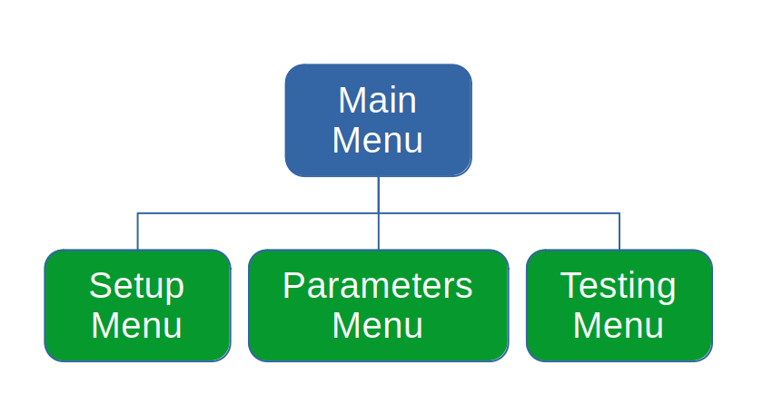
4. To change a parameter first, select then, press the +/- on the top left to adjust the parameter.
5. To indicate testing the play button on screen turns red. By default the button is green as the test is not running.
6. The entire interface uses a simple single depth interface for navigation. (See diagram)

3.2 Setup
To begin the tester can be placed in 2 different ways: either placed on a flat surface or positioned so the tester spans a gap between two flat surfaces (ex: 2 tables). The latter method is preferable as it allows more room below the tester for the bridge to extend during testing. This allows the tester to completely finish the test automatically without the tester being lifted by the actuator combined with the extra thickness provided by the bridge.
Ensure the tester is also positioned near a power outlet. Next, plug in and turn on the tester. This can be done by releasing the emergency stop, start by turning the red button clockwise while slightly pushing down until it stops then release. The button should pop up and the tester should turn on and the power LED should light up (arrow shown below). Wait 5-10 seconds and the following should be displayed on the screen.

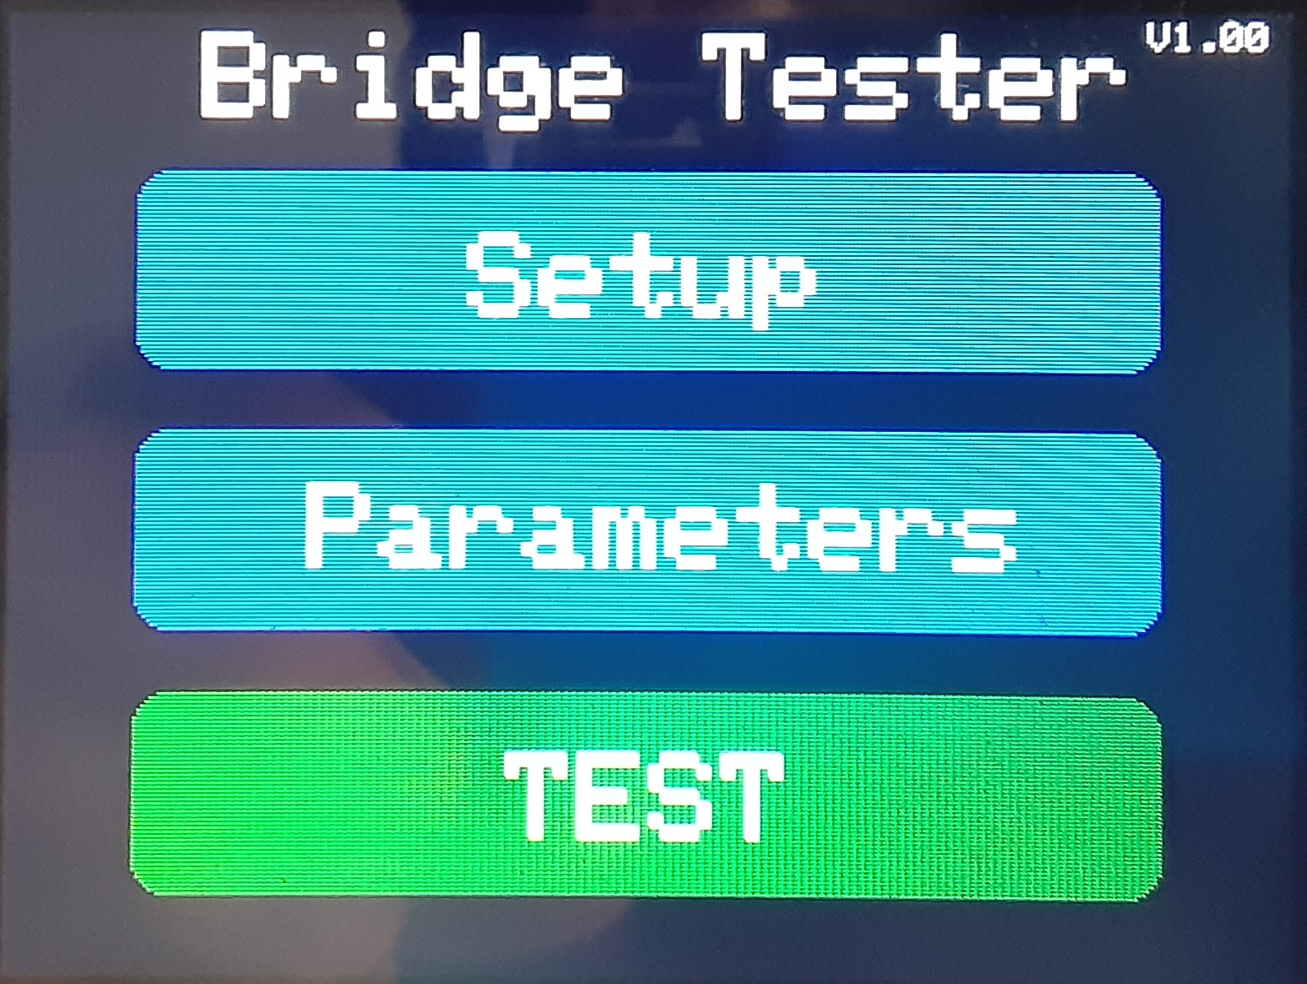

Select the “Parameters” menu.

Use the “+” and “-” buttons to change to the desired load rate (2 - 9.9 lb/s)

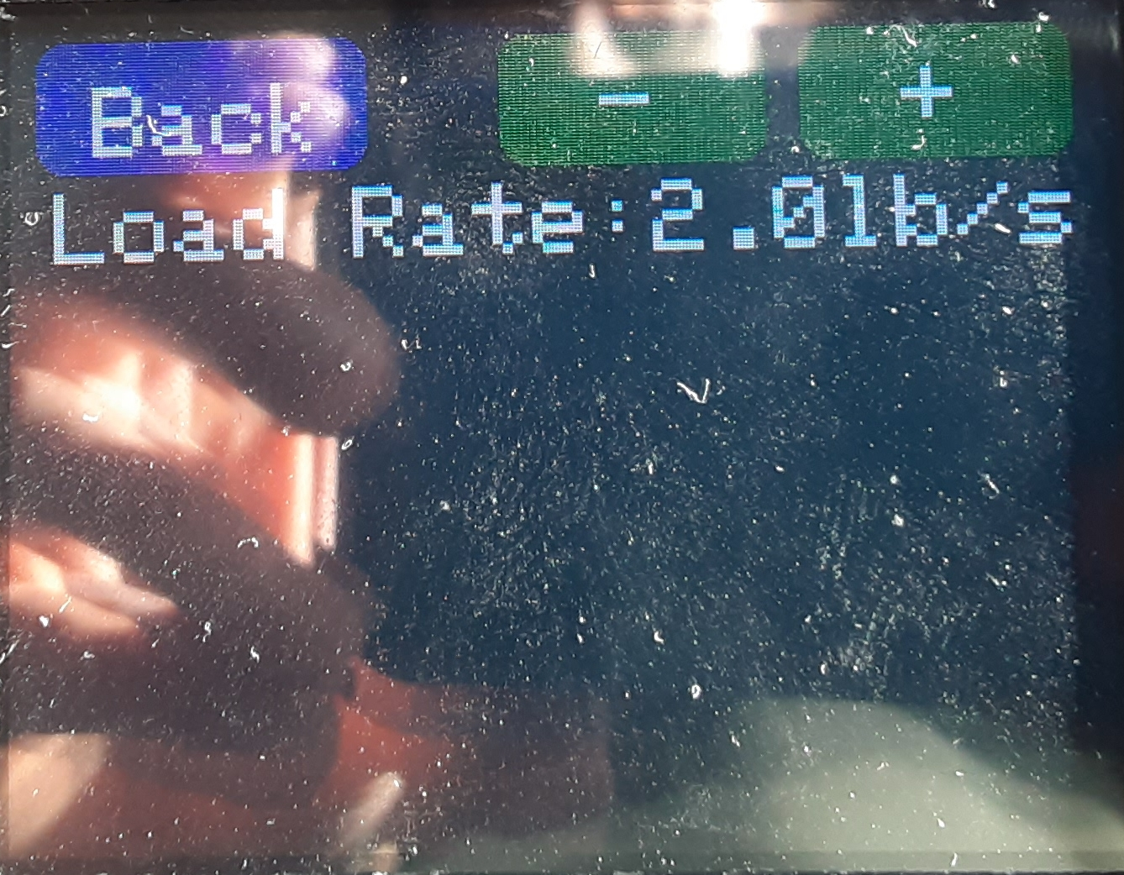

Select the “Setup” menu

This will bring up the following. Select “Load Rate:” by pressing on the “Load Rate:” text when selected it will turn green.

To finish simply press “Back” this saves the load rate for future tests even if the tester is powered off.

From here, place the bridge on the tester. If the loading mechanism is too low first raise it using the “Move Down” and “Move Up” buttons. If needed adjust the speed using the “+” and “-” buttons.

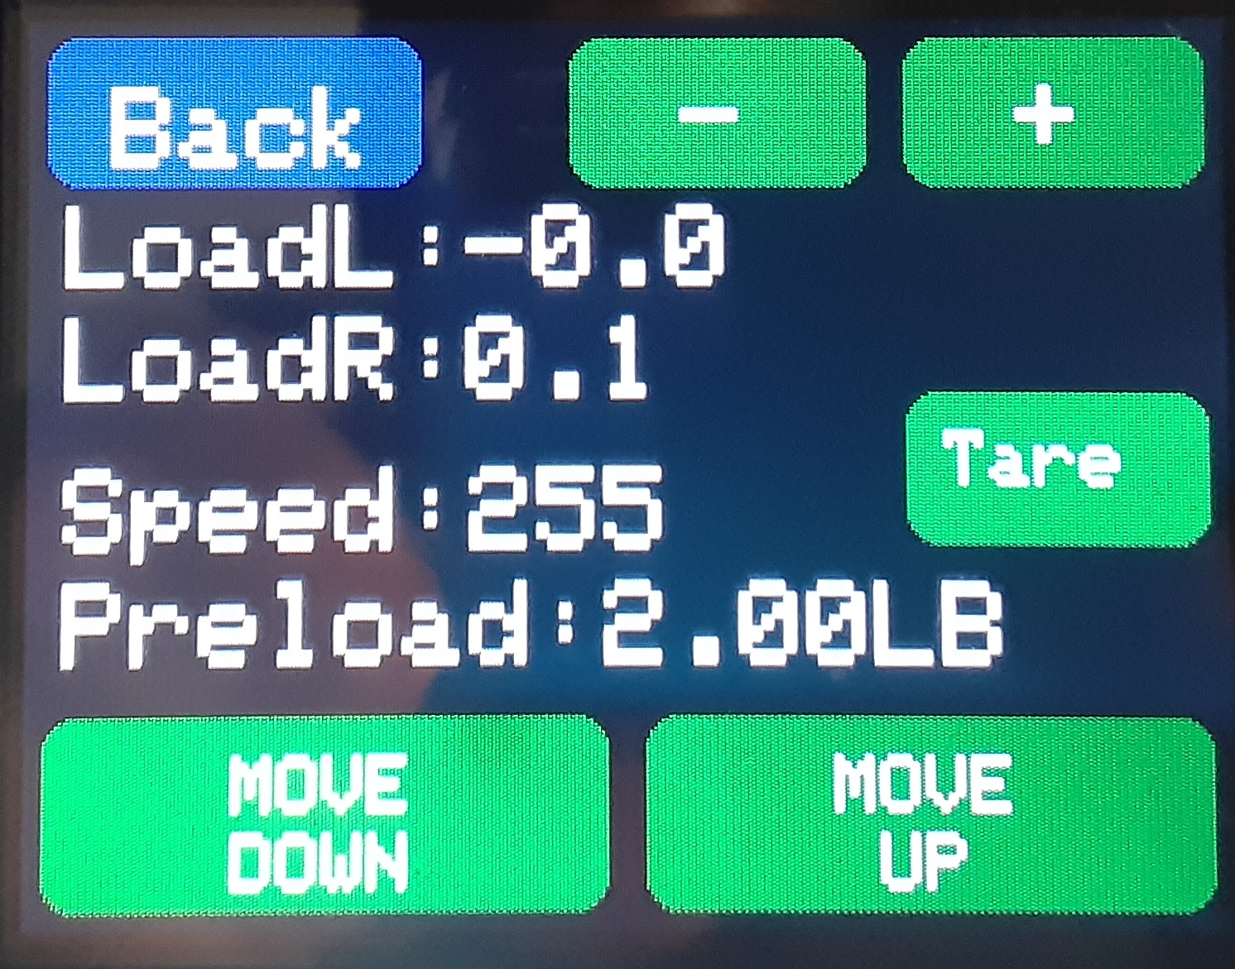

Select “Preload” and adjust this value to your desired value (0-20lb). Note preload is the starting load that gets applied to the bridge before the test begins. Preload is still added to the overall score when testing. A typical value of (2-5lbs) is recommended. This ensures the actuator in later steps remains in the same spot after you release it.

From here add spacer blocks if the bridge is less than 2” tall and move the actuator down. When you are within ½” of the bridge slow the motor speed to reduce overshoot on the preload. A good value for the speed would be around 50-100. At this point hold the actuator so it is centered and continue moving the actuator down until it stops.

Now without applying any additional force on the bridge press the “Tare” button. This will subtract the weight of the bridge from the final result and “LoadL” and “LoadR” should read near zero.

Once the preload has been reached the actuator will stop moving down. “LoadL” and “LoadR” will display the current force on each side. If a large difference is present you may wish/need to bring the actuator up and re-adjust the left, right balance by slightly tilting the actuator to the side that has the lower reading. Repeat this process until the desired balance is achieved.

3.3 Testing

Now the tester is all ready to perform a test. Press the “Back” button.

This will bring up the test menu that displays the max load recorded in pounds, the current load in pounds, and a graph of the load.

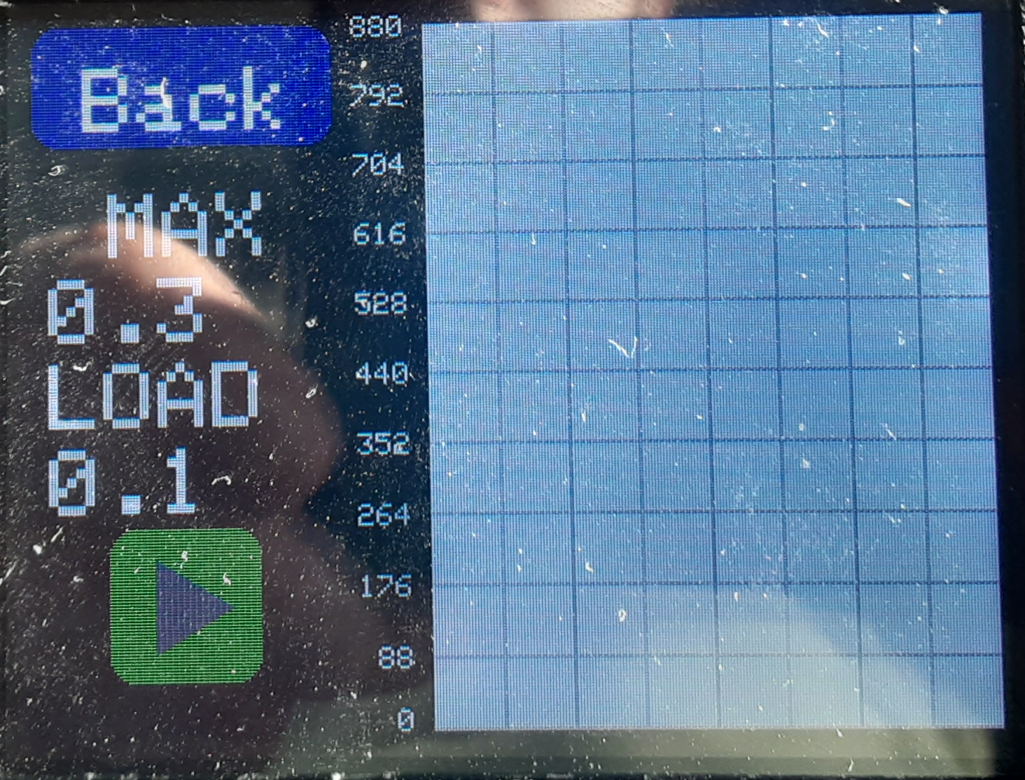

When the play button is pressed it will turn from green to red to signify that the test is currently running.

Testing paused Testing



Press “TEST”

To start the test press the play button.
Note: The entire area circled can be used to trigger the play/pause button.

In the event of an emergency simply press down the big red button on the from of the tester. This will remove power from the entirety of the tester.

3.4 End Testing and System Reset

At the end of the test the actuator will return to the up most position followed by the activation of the status LED (arrow shown below).

To reset the tester hold down the play button for at least 5 seconds. This will reset the maximum value and bring you back to the main menu to setup a new test.

If the LED shows Green the test finished without errors. However if the LED shows red this indicates the test ended because one of the load cells reached it’s maximum. If the latter is the case and the max load is less than 880lbs the test may be re-run to try to either break the bridge or obtain a higher score.

Test - Successful Test - Load Cell Max

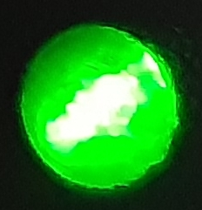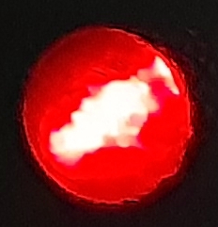

4. Design Info

4.1 Electrical

4.11 AC Power Input
The tester takes power from a U.S. standard NEMA 5-15R receptacle. Provided with the tester is a NEMA 5-15P to IEC 320-C13 to make the connection to the tester. The input should be 120V +-10% 60Hz. The side of the electrical enclosure houses a IEC 320-C14 that the included cord can be plugged into. From this connector 3 connections are wired through the enclosure wich includes, earth ground, neutral, and live. Ground and neutral get connected directly to the 12V power supply where as live get connected to the emergency stop switch and then passes to the power supply (see diagram below). This allows all power to be cut to the tester in the event that something goes wrong.
Key:
Green – Earth Ground
White – Neutral
Black – Live

4.12 Power Supplies
The tester makes use of several power supplies to achieve it’s functionality. This includes 1 off board supply and 5 on board supplies. The main power supply is a 12V 8.4A industry standard 1U power supply. This provides power for the linear actuator as well as all subsequent power supplies. From here a switching regulator takes the 12V and outputs 3.3VD for the MCU, Motor Driver, and ADCs(Digital only). This is treated as a dedicated digital supply to help reduce any noise that the digital parts kick back onto the power rail. Also from the 12V rail 7VA is generated using a linear regulator. This supply is solely used as a pre-regulation stage to some of the other regulators and as a bias supply for the load cells. From the 7VA rail 2 supplies are derived 2.8VD and 3.3VA. 2.8V is used by the LCD for some internal function where as the 3.3VA powers the analog section of the ADC. From the 3.3VA rail a -5VA rail is generated also for the function of biasing the load cell. 7V and -5V combined were chosen to allow the ADC’s input to stay within the common mode input requirements which is -0.3 – AVDD + 0.3. In addition the two voltages also total the maximum voltage rating of the load cell of (7 + |-5| = 12V) making measurement slightly better. The load cell forms a whetstone bridge that nominally divides the voltage applied across by 2. This means that the voltage midpoint is around 1V and is within the ADC required specifications. It should be noted that the -5V rail got changed to -3.3V due to a misunderstanding in a data sheet. This still keeps the midpoint at 1.85V so it is still within range however this reduces the overall applied voltage by 1.7V so the load cell outputs a even smaller reading over the entire span (reduced by 3.4mV).

4.13 MCU
At the center of the tester is a RP2040 with 16MIB of on board flash memory. This MCU controls everything from the ADCs to the Motor controller, and touch screen. The RP2040 is a dual core ARM Cortex-M0+ @ 133Mhz with 264kiB of RAM. This MCU was chosen for its good IO, peripherals, speed, and cost. Key features include USB support for direct program upload without the need for a self developed boot loader.

4.14 HID
A single 320x480 RGB resistive touch screen was used for it’s feasibility as well as it’s low cost. This allows for very little planning on the interface side in the early stages of the project as all buttons use the touch screen. Additionally 2 LEDs are also provided to indicate power and testing status.

4.15 Motor Driver
The motor driver manages the 4 N-Channel MOSFETs in a H-bridge configuration. This includes an in integrated charge pump, Fet drivers, and Current shunt amplifier. The FETs were chosen to have a low RDSon and reasonable gate charge to allow for favorable static and switching characteristics. The shunt amplifier is particularly nice as it allows the controller to detect when the limit switch for the motor has been triggered without needing a separate amplifier to be designed for this function.

4.16 Load Cells
The load cells for this tester have the ability to measure up to 200kg(440lbs) each meaning that the total force applied can be 400kg(880lbs). They have an output of 20mv/V (full span) meaning if 200kg were applied to the load cell and 1V was applied the load cell would measure 20mv. The maximum voltage allowable is 12V meaning that each lb is about 54μV(MAX). To measure this small voltage serval techniques are used to get good results. First a 24bit ADC is used this allows for direct measurement as with a 3.3V reference each LSB is about 197nV far lower than the needed increment. The chosen ADC the MCP3561RT-E/ST has additional features including a programmable gain amplifier and automatic oversampling to help aid in the measurement. Additionally in software a rolling average is applied to the samples to improve consistency reducing jitter. If the system was to go though a second revision It would be good to place a LNA in between the load cell and the ADC to better drive the ADC. This would help to reduce the offset caused by the relatively low input impedance of the ADC.

4.2 Software

4.21 Libraries
SPI.h – Used for easy acess to the the on chip spi hardwear for LCD and ADC communication.
Adafruit_GFX.h – Contains basic graphics functions like drawing text and other objects on a screen.
Adafruit_ILI9341.h – Basic driver for the LCD driver IC.
SingleFileDrive.h – Makes use of the on board USB port to enumerate as a usb flash drive with a single file was going to be used for data output but was removed (not used)
LittleFS.h – A high reliability file system for embedded applications that has power loss protections. This gets used for storing parameters within a dedicated section of the program memory.
EEPROM.h – Interfaces with littlefs and the on board flash to write to a dedicated address as if it was an internal EEPROM on chip. Used for storing settings set by the user.
pico/mutex.h – A basic mutex from the RPI SDK. This allows safe access to a singe memory address to both of the 2 cores on the RP2040 ensuring that both cores do not try to read or write from the same address at the same cycle.
PID_v1.h – A quality PID implementation originally it was going to be used for the load rate control loop but proved to be more work that it was worth to tune the parameters and get a better result.(not used)
Rpi_Pico_TimerInterrupt.h – A breakout of the internal timer interrupts from the rp2040 (not used)

4.22 Functions
ADC_Take_Reading – Starts and waits for an ADC conversion to occur for both of the load cells.
Get_ADC_Register – Takes in what ADC you wish to read from as well as the register address number.
ADC_Read_Value0 – Call at the end of each read interrupt call from a ADC0.
ADC_Read_Value1 – Call at the end of each read interrupt call from a ADC1.
SPI_Restart – Restarts the SPI Interface.
Start_Motor – This changes the state of the NSLEEP pin so the motor controller is taken out of sleep mode and allowed to run the motor.
Update_Motor - This writes the current motor speed value and direction to the controller and makes the motor move as directed.
Stop_Motor – This puts the motor controller in sleep mode so that the motor can no longer run.
Motor_Current – Gets the current motor current measured by the internal amplifier and external shunt amplifier.
Main_Menu – Houses all the code used to run the logic for the main menu.
Setup_Menu - Houses all the code used to run the logic for the setup menu.
Test_Menu - Houses all the code used to run the logic for the test menu.
Parameters_Menu - Houses all the code used to run the logic for the parameters menu.
Touch_Screen_Sample_x – This function handles the measurement of the x coordinate of the touch screen this includes any averaging that might be needed to get good results.
Touch_Screen_Sample_y - This function handles the measurement of the y coordinate of the touch screen this includes any averaging that might be needed to get good results.
Check_Box_Touch – Creates a touch rectangle bounded area that can be used to act an input for some other function.

4.23 Uploading Programs
Uploading programs to the RP2040 is very easy and can be done in 2 ways. Using method 1 required a bit more work to start out but offers the ability to make code changes as well as not needing to remove the top electrical cover of the bridge tester.

1. Using Arduino IDE. First start by downloading and installing Arduino IDE. Then open up Arduino IDE going to file → Prefrences → Additional Board Manager URLs and pase in “https://github.com/earlephilhower/arduino-pico/releases/download/global/package_rp2040_index.json”. From here click OK. Go to Tools → Board → Board Manager. Type in “pico”. Select install on the library that says “by Earle F. Philhower, III”. Wait for the process to finish. Go to Tools → Board → Raspberry Pi Pico/RP2040 Generic RP2040. From here go back to Tools and make sure that the settings shown in the Red box are set the same as in the picture. From here plug in the tester using a usb-C cable. Arduino should auto select the board but if not click the drop down box at the top of the screen before the tool bar and select the RP2040. From here simply click the arrow button circled in Green in the picture. The program has just been uploaded as long as no errors popped up.
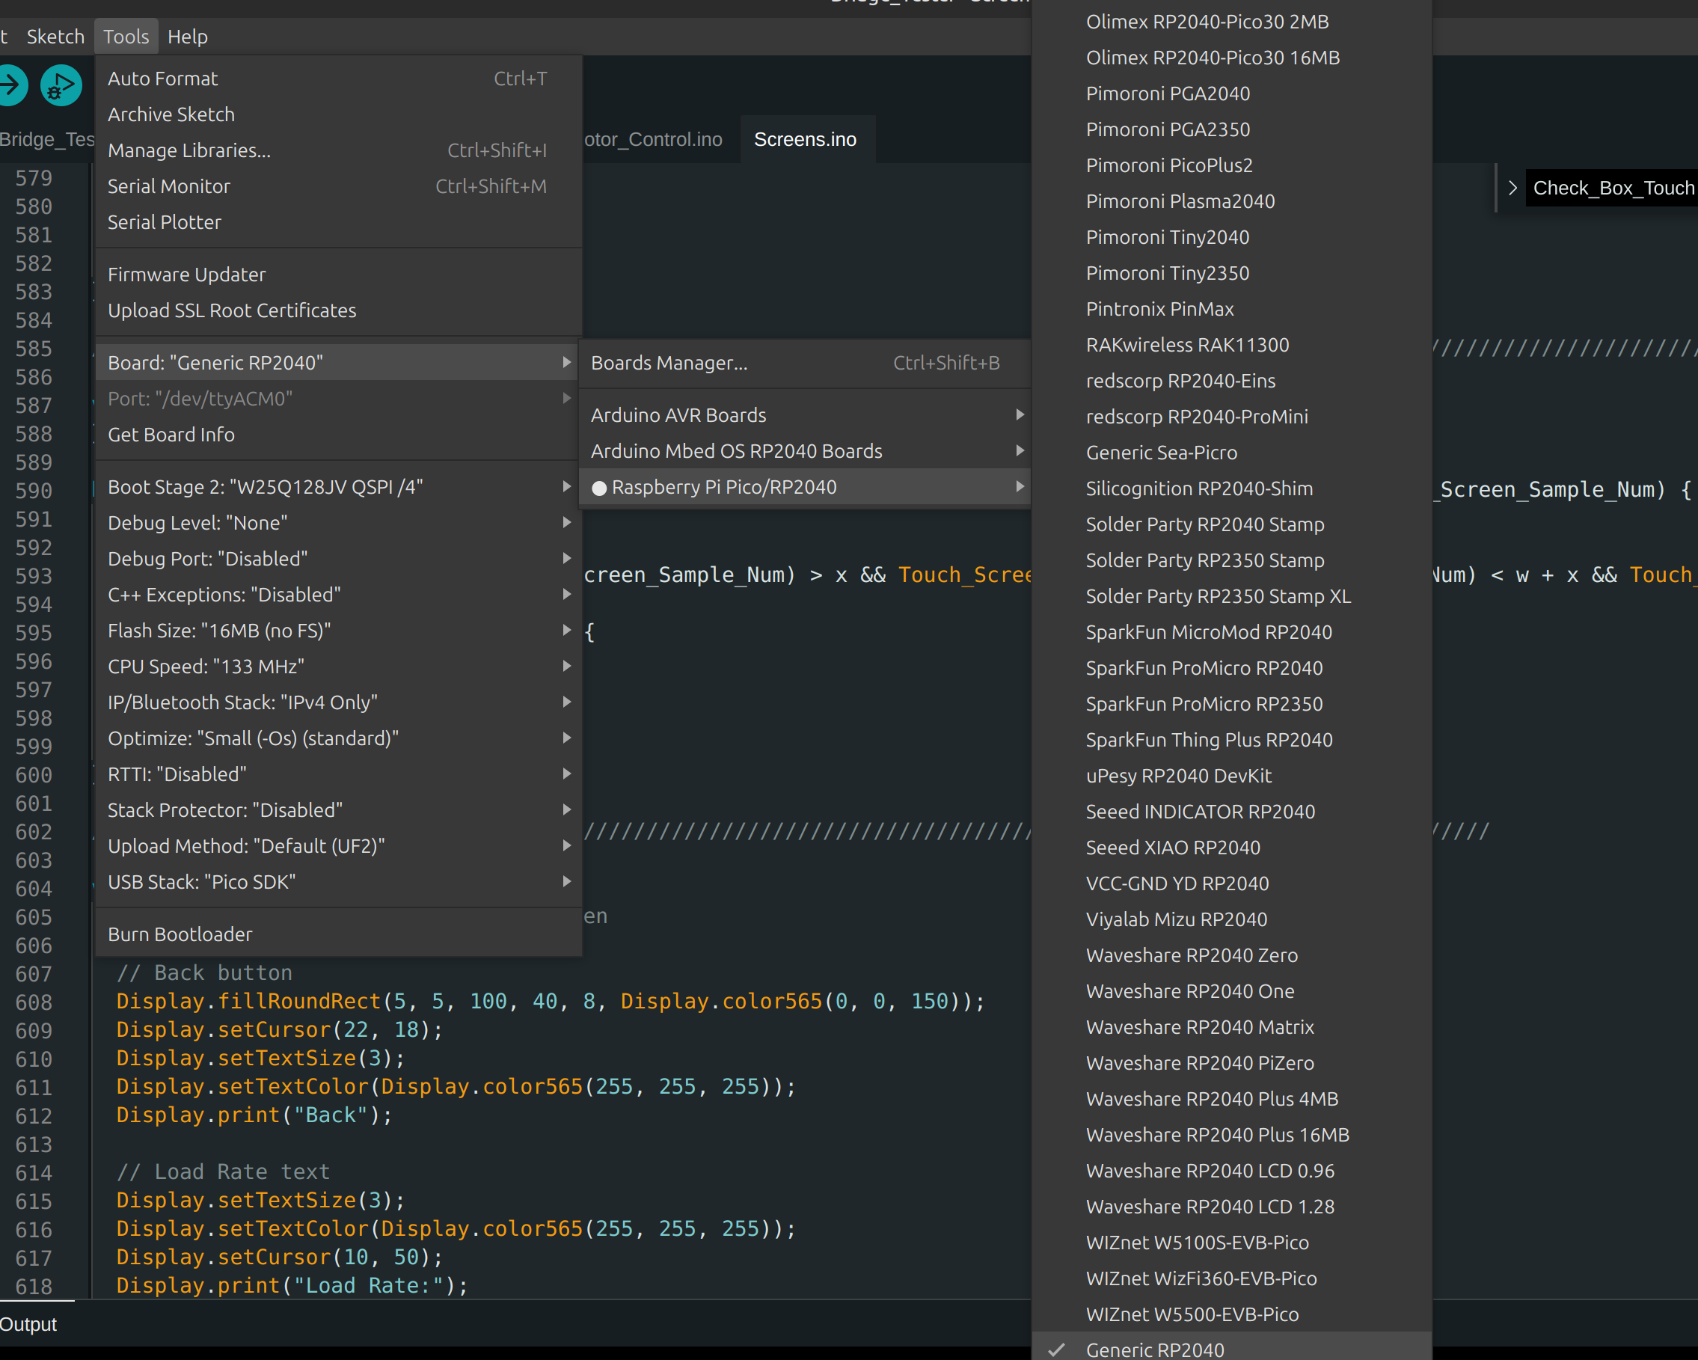

2. Using a pre-compiled .UF2 file. Start by removing the top electrical cover from the Bridge Tester. Locate the Reset and Boot Select Buttons. Plug in your USB-C Cable to your computer and the tester. Now hold down the boot select button and briefly press the reset button. Finally stop pressing the boot select button. At this time you should be able to see the RP2040 on your computer as a USB flash drive. Simply drag the UF2 file onto the RP2040 USB drive and wait for it to disconnect. Once it disconnects the programming process is complete.

5. Definitions
ADC – Analog to Digital Converter
HID – Human Interface Device
LCD – Liquid Crystal Display
LNA – Low Noise Amplifier
LSB – Least Significant Bit
MCU - Micro Controller Unit
PID – Proportional Integral Control
RPI – Raspberry PI
SDK – Software Development Kit

